PROJECT SCREENSHOTS
Server Start
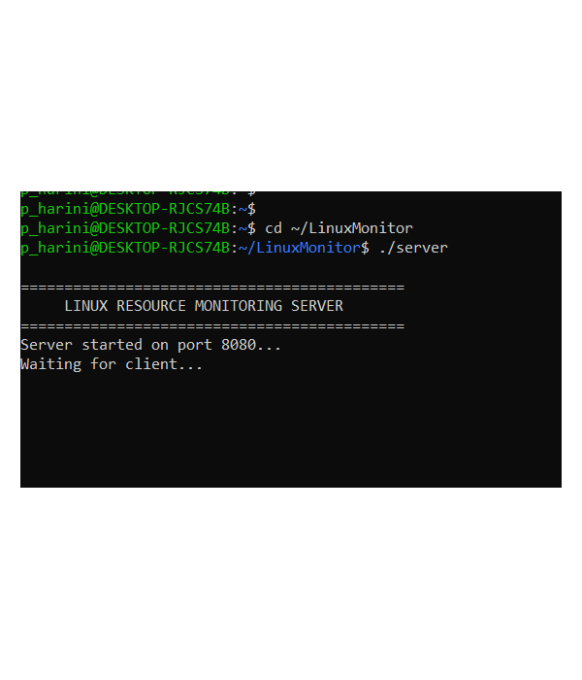
Client Connection
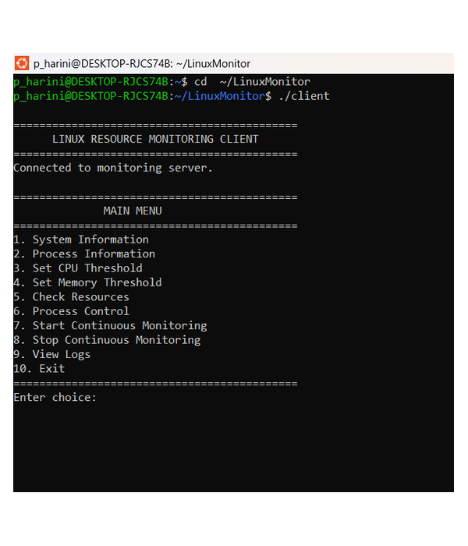
Enter Choice 1 – System Information
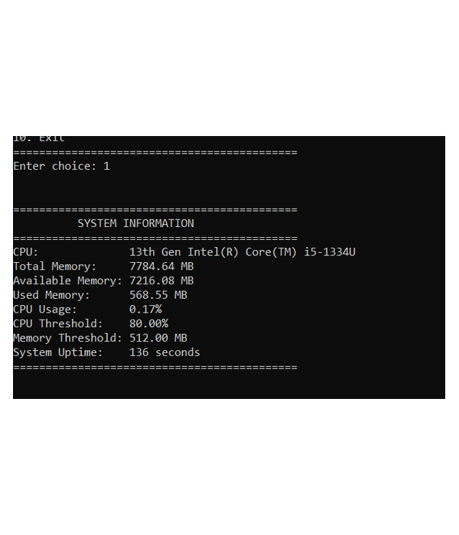
Enter Choice 2 – Process Information
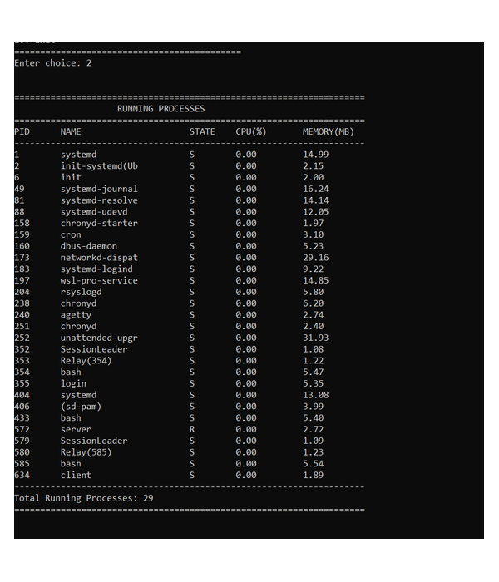
Enter Choice 3 – Set CPU Threshold
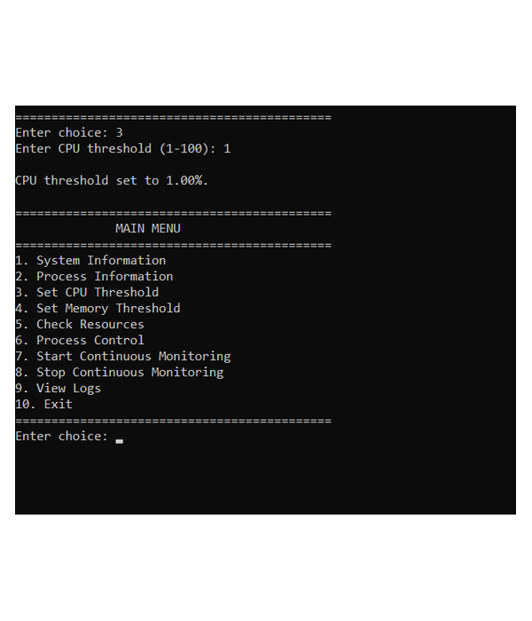
Enter Choice 4 – Set Memory Threshold
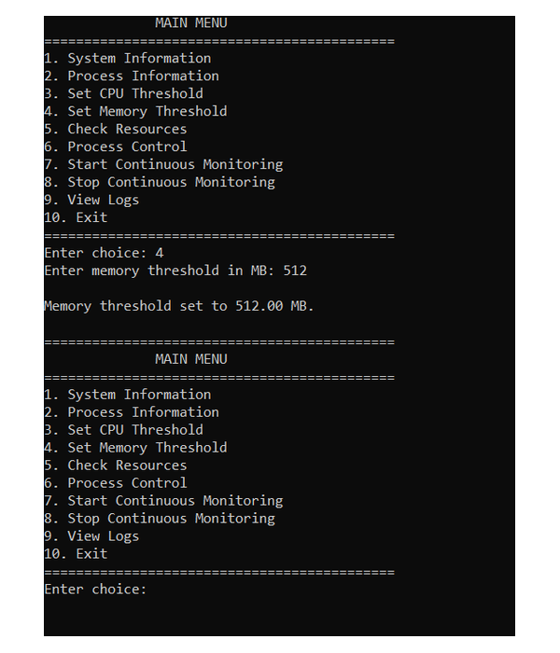
Enter Choice 5 – Check Resources
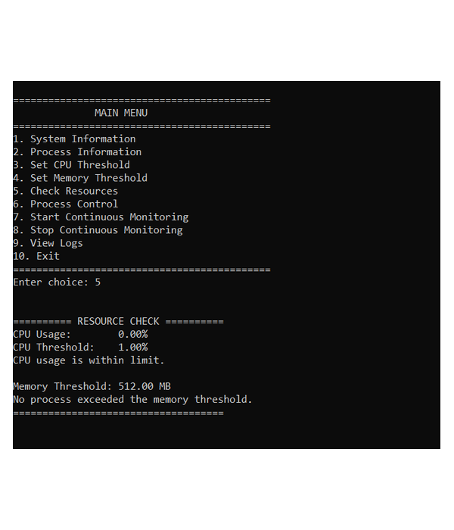
Enter Choice 6 – Process Control
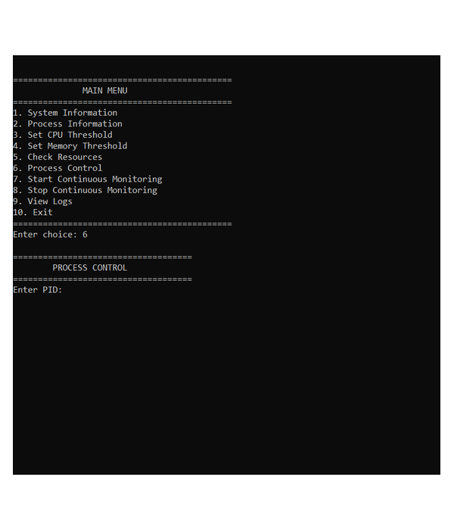
Process Control – Test Process
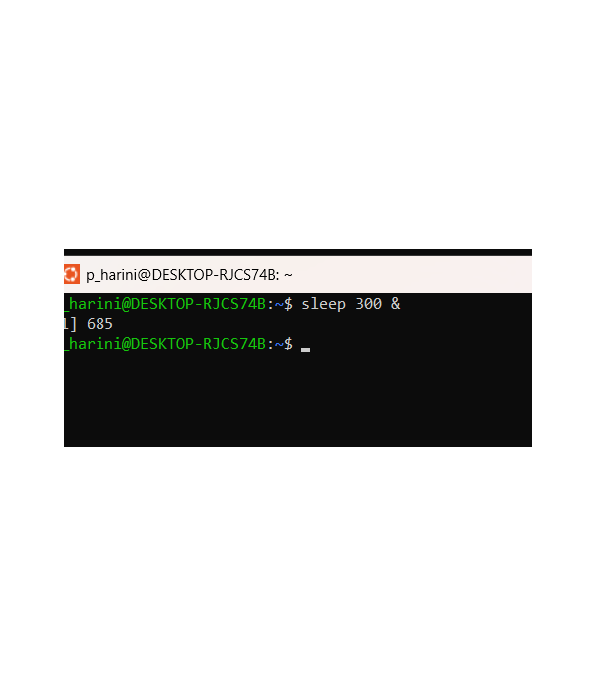
Enter Choice 6 – Process Control
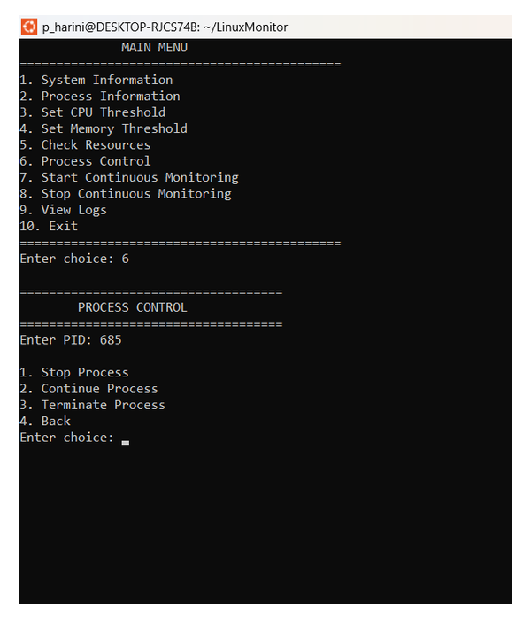
Enter Choice 6 – Process Control
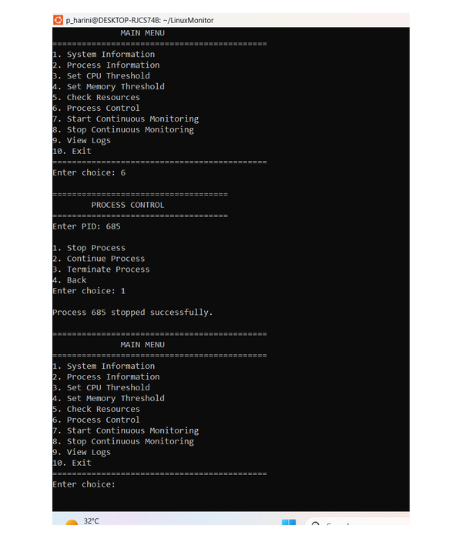
Enter Choice 6 – Process Control – PID Selection
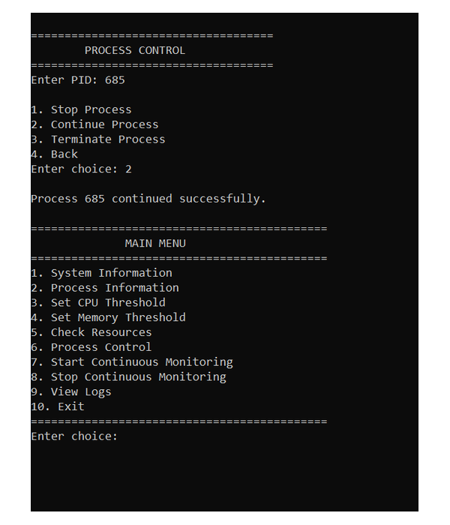
Enter Choice 6 – Process Control
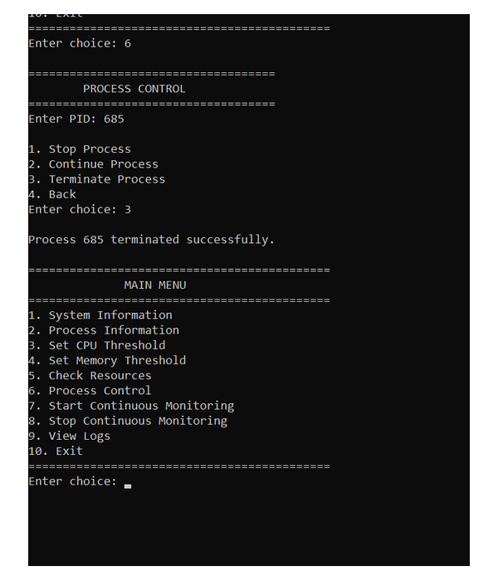
Enter Choice 6 – Process Control
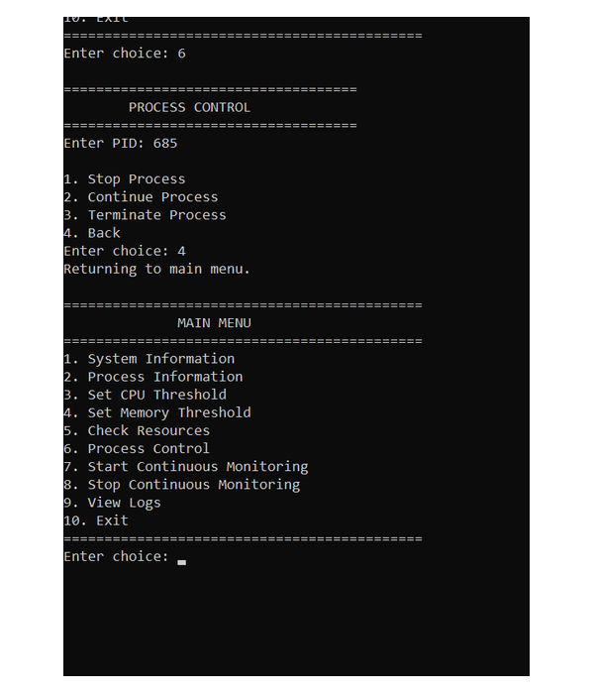
Enter Choice 7 – Start Continuous Monitoring
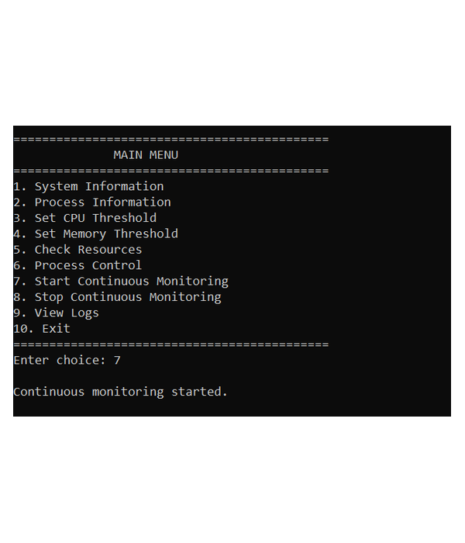
Enter Choice 5 – Check Resources / Resource Status
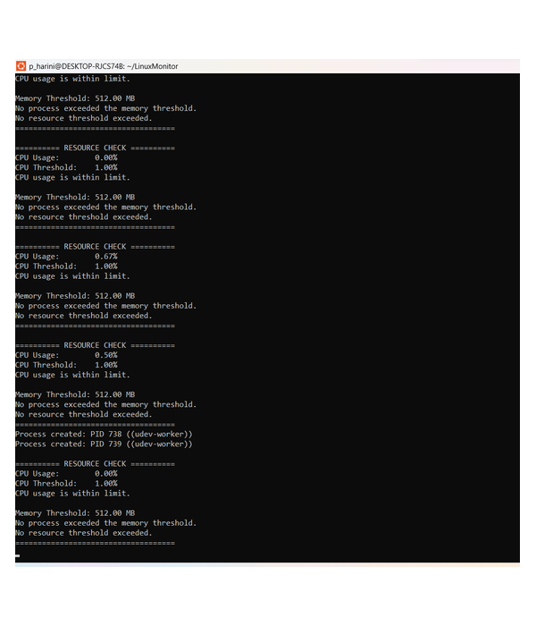
Continuous Monitoring – Process Activity
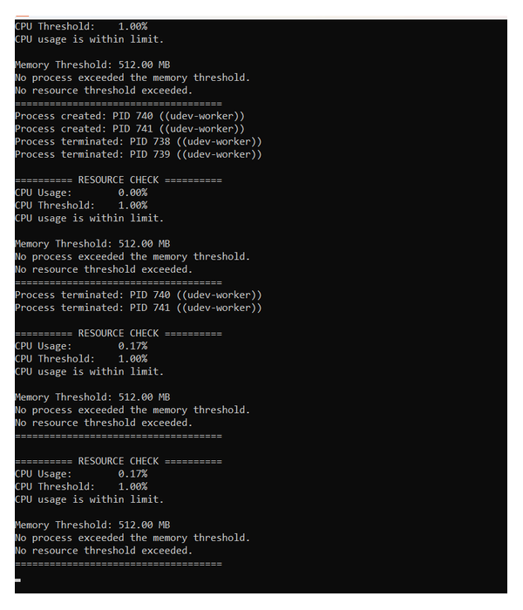
Enter Choice 8 – Stop Continuous Monitoring
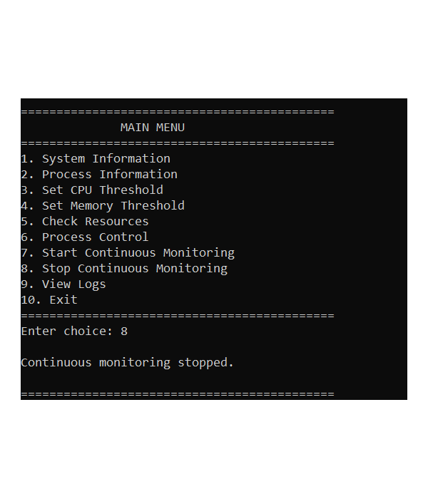
Enter Choice 9 – View Logs
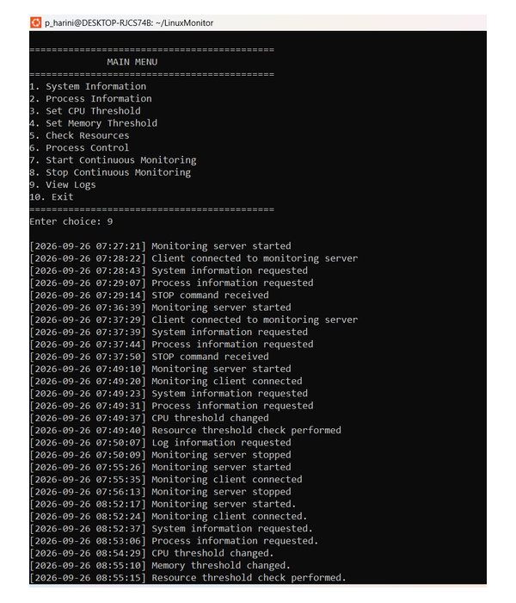
Enter Choice 9 – View Logs – Log Details
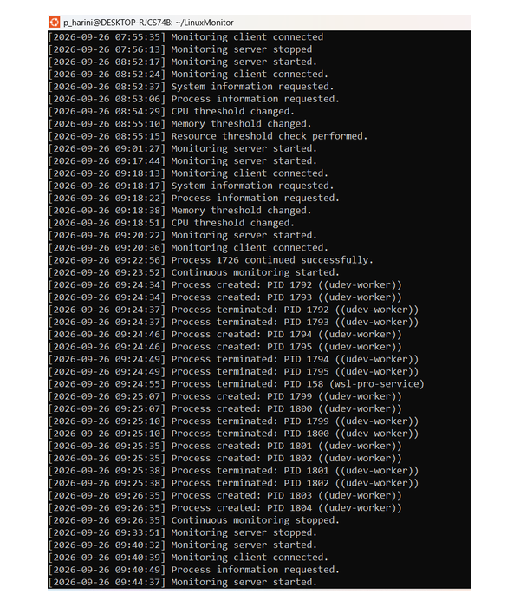
Monitoring Log Output
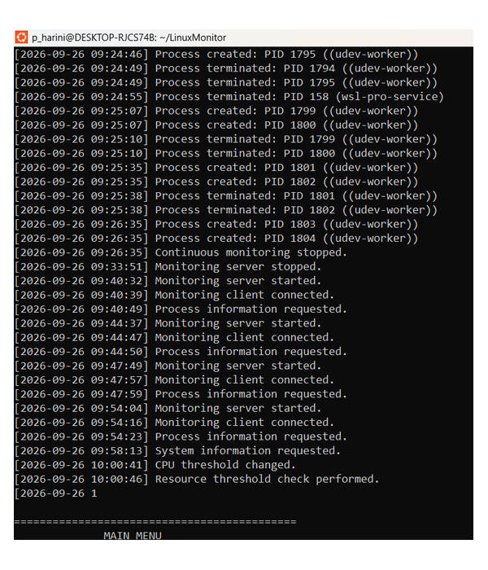
Enter Choice 10 – Exit
